# Using Audit Engagements & Workpapers

The Audit Engagements & Workpapers use case supports the following processes.

On this page

* Audit Engagements & Workpapers Process
* Managing audit readiness
* Defining audit entities
* Creating plan entities
* Managing audit engagements

## Audit Engagements & Workpapers Process

Download the source file of the diagram here: [Audit Engagements & Workpapers Process Diagram](../../Resources/Images/Solutions/Audit/am_audeng_process.vsdx)

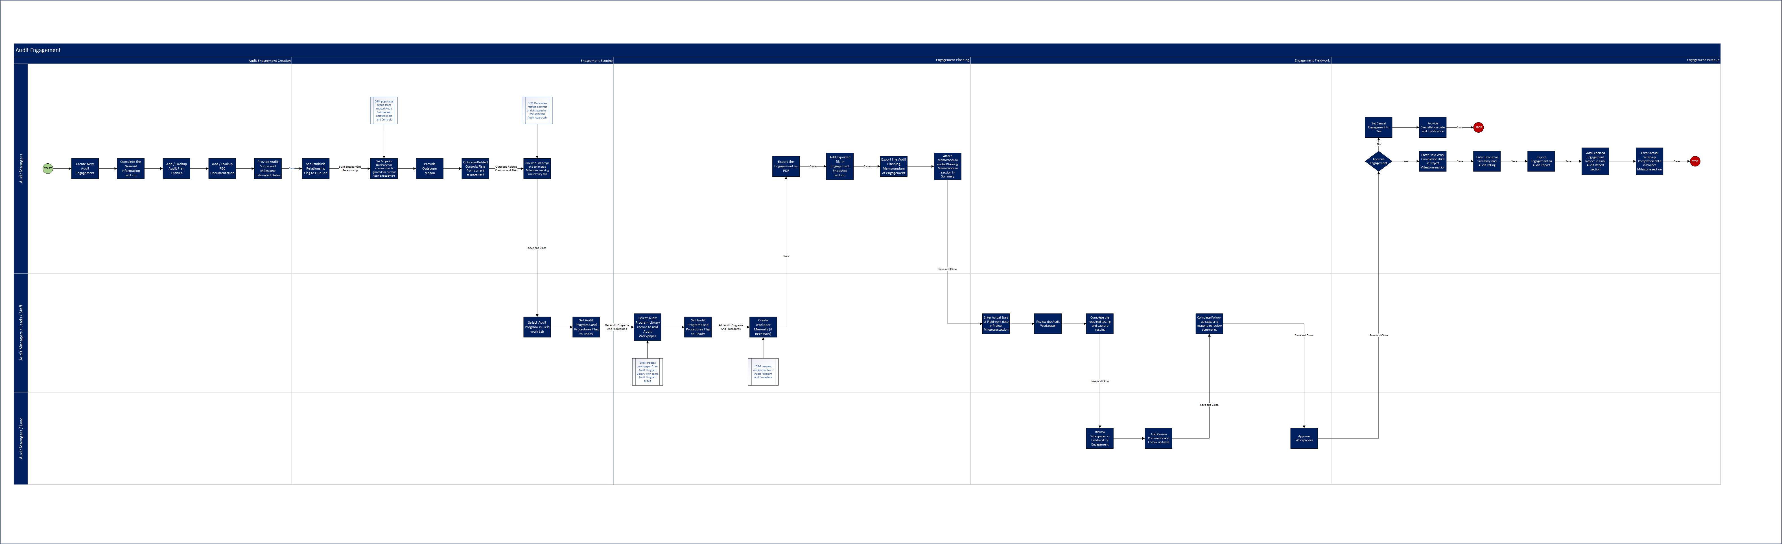

## Managing audit readiness

The Audit Engagements & Workpapers use case allows you to do the following:

* Document information about audit staff members and external contacts.
* Document your teams and capture the skills of each team member in order to help assign the right auditors to engagements.
* Create a library of standard audit programs and procedures that can be copied into individual audit engagements for greater overall consistency.

## Defining audit entities

Through the Audit Entity application, you can:

* Define each audit entity and create a "universe" of audit entities. Based on the business processes you select, the system can auto-scope the audit entity by gathering related facilities, applications, and devices.
* Define each audit entity by relating the entity to cross-referenced records (for example, business processes, applications) in other applications.
* Assign audit and business ownership to each audit entity.

## Creating plan entities

Each time an audit entity is identified as a target for an audit engagement, a plan entity record is required in order to accurately link the audit entity to the audit engagements. The plan entity captures information about the type of audit engagement, the objective and scope, and the stakeholders, which may differ from engagement to engagement.

For example, 1 year you may decide to include an audit entity in an engagement as just a Department Review, which requires a limited scope. In the next year, you may include that same audit entity in another engagement, but this time as an Operational Audit, which requires more resources and a larger scope. Separate plan entity records are required so that you can scope different elements of the audit entity for each engagement.

Here are the tasks to create plan entities:

1. Determine which audit entities to audit.
2. Create plan entities.

## Managing audit engagements

Use the Audit Engagement application to manage the audit engagement through its lifecycle. Create and scope the engagement, assign resources, out scope content ignored for the current audit engagement, generate workpapers, document and review observations, complete fieldwork, manage findings, track the tasks associated with the resolution, and complete wrap-up on the engagement.